JavaScript Testing Framework Instructions: QUnit
Moiz Nizamuddin

Table of Contents
Introduction 3
Setting up the JTF 3
Using the JTF 5
Tests That Pass 6
Tests that Fail the API Call 7
Modifying the JTF 7
start.html 7
qunit.js 8
The Tests Folder 8
API Tests 9
Response Validation Tests 9
Modifying Throttling Setting 10
Adding to the JTF 11
Adding a New Test Suite 12

Introduction
The JavaScript Testing Framework (JTF) is a tool designed to assist in making API calls from JavaScript, or client-side, code, proving that the client-to-server communication files, as well as the server files, are functioning properly. The code in the framework sends requests to the Provider library, which is the intermediary for client-to-server communication. The Provider code forwards your request to the server you are using. Then your Ruby, your PHP, or your Java server makes the call to the web service. If an error occurs, the JTF helps isolate the issue and gives clues on how to fix it. The JTF automates the process of testing the API calls. Now a single click can run hundreds of test cases, with results displayed in a nice, clear chart.
This JTF version is easy to set up and use, requiring minimal interaction with code. This document details how to set up and work with the JTF. Suggestions are also made on how to go about adding tests to the framework.

Setting up the JTF
The JTF folder should contain two folders, “client” and “server”. Client is set up like this:
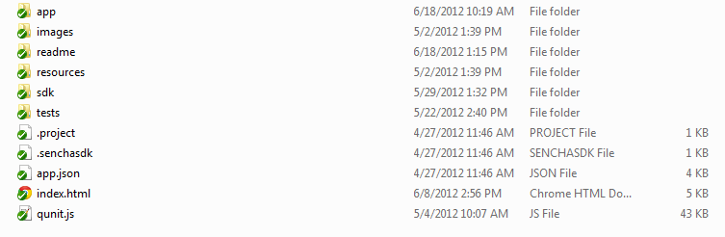
Folders:
app – Contains the controller and view files for the framework, including pages and test sweeps. Also contains the Provider.js file for client-to-server communication.
images – Contains the images used by the framework.
docs – Contains helpful information, like this document.
resources – The css file that creates the look and style of the test results page.
tests – JavaScript files with the actual test functions.
Files:
start.html – Controls some display of the application and loads various dependencies.
Qunit.js – A suite of code to display the test results in an easy-to-understand format.
The API client is located at webcontent/lib/att-api-client.js. That file makes the client-to-server calls. Changes there affect how the calls are made, which is what this framework tests.
The “sdk” and “resources” folders may need to be swapped with the most recent ones from a code drop as well, if something there changes.
The server folder contains three backends, one each for the Ruby, PHP, and Java servers. The Ruby server is the easiest to set up and use, but PHP works well too. The Java server works but is buggier, sometimes calling the asynchronous Success functions even when it receives a 400 series bad request. Some Java server bugs need correcting, and that is happening. These server folders are updated with each test cycle, and should be ported to the JTF so that it tests the latest code in every cycle. You must also update the properties file in the “conf” folder with the latest keys and the proper endpoint to run each new application you create on Devconnect. For example the Ruby server conf is located at ‘att-html5-sdk/sdk/server/ruby/conf/att-api.properties’
The client folder must reside in the webcontent directory in order for the tests to run. If this is not the case the tests will not run.
After making these updates, you are ready to run the JTF. Use the command prompt to navigate to the JTF/server/ruby/example folder, and then type “ruby app.rb” to start the server that runs the application. You may use similar startup processes for the Java and PHP servers, much as you would when deploying the SDK.
To use the Ruby server, open the Chrome browser and type “http://localhost:4567/client/start.html” to start the JTF application. If you use a different server, you need to go to a different port.
When things work properly, you now see the screen below with your testing options.
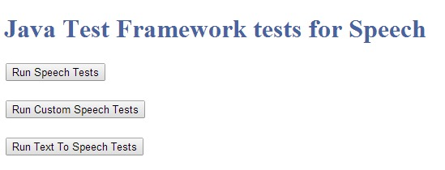
Running a test such as Text To Speech Tests will run tests and display the details such as this:
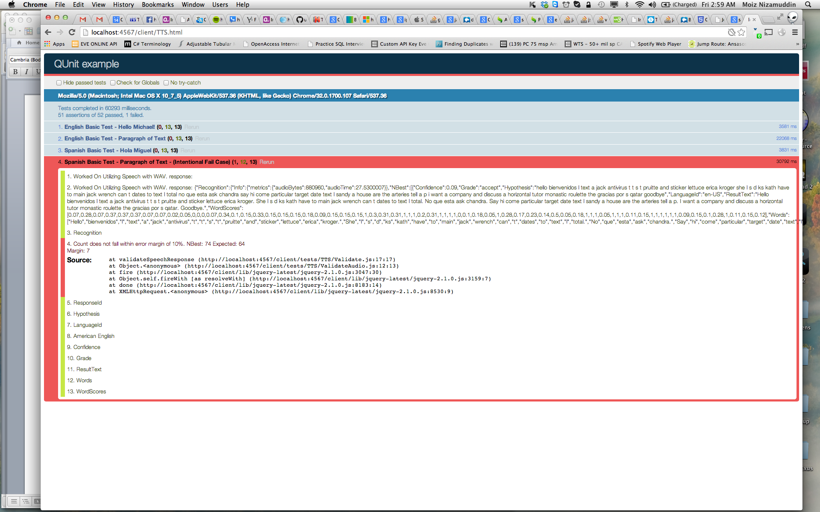

Using the JTF
The screen should appear as above. There are different options for various test segments you can run. The current tests verify that the API is properly making a call to the SDK and is receiving valid results. (This does not mean that the SDK is returning 100% accurate results, but that the API is communicating with the SDK and is not altering any data being received).
The current tests contain primarily positive tests and some negative tests. Negative tests will display as a fail and are marked as such in their test header.
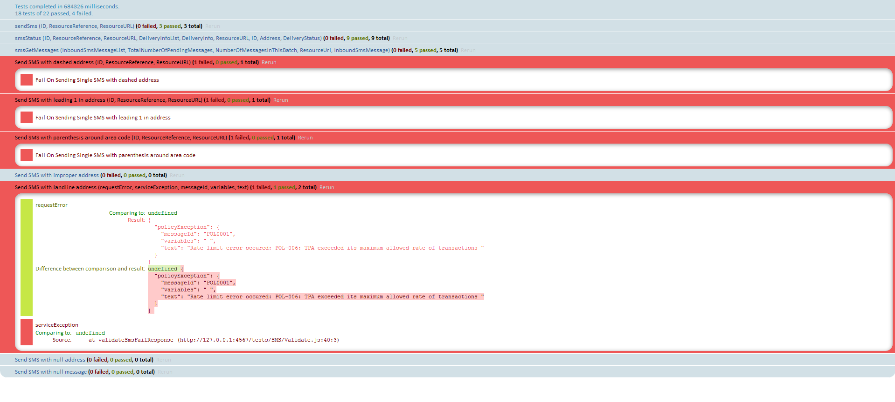
A test sweep might look much like the image above. The chart contains 3 types of results. Some tests pass. Others fail to make the desired API call. And some tests fail to contain the items expected in the response. Each situation is worth further examination.

Tests That Pass
This test passed, as indicated by both the blue color of the row’s background and that it shows “0 failed” on the left. In order to pass, the test must both produce the expected API call results and the expected response objects. The first is self-explanatory. We expect the call to successfully convert the Text to Speech. Since it does, it produces the expected API call result. In this particular test, it then validates the Speech response by sending the audio back to the server to convert back into text.
API calls are requests, and these requests generate response objects. We know which parameter names should be present in the responses. In some cases we know what the parameter values should be, too. Here we only know the former, so we just check for the existence of these parameters.
If you click on the blue test name, that part of the table expands and you can examine the parameter checking more closely.
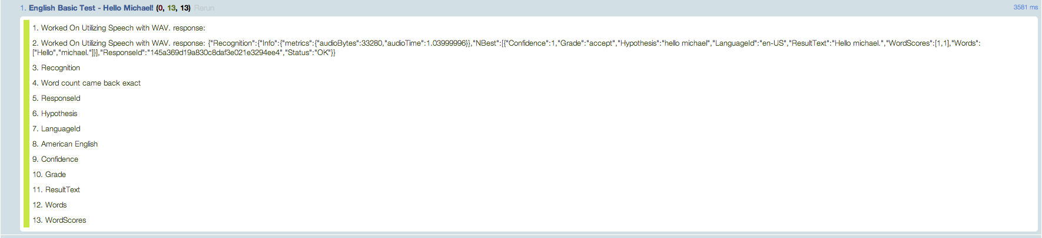
Each section of this expanded view details the testing of a particular parameter. The first checks that the text was successfully sent to the server in which we received a response. We then grab the response and verify that it wasn’t garbage, malformed, etc... That is because, while we know there should be data in the response, we want to have a means of comparing to make sure it’s similar to what we sent . From then , we check to make sure that the properties of the response are intact and are not malformed as well.
In part 4 of the test, we make sure that the amount of words that came back are within a 10% margin of error. Meaning that if there are 20 words, the amount of words resulting from the speech check should be between 18 and 22 words.

Tests that Fail the API Call
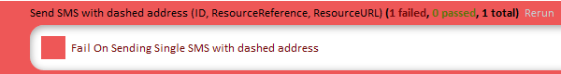
This test failed to produce the expected result. The API call, sending an SMS with dashes in the address (123-456-7890), did not work. The message did not get sent even though it was expected to. Many possibilities for the failure exist. The function to remove the dashes may not work. This is just an example to see what failed tests are like

Modifying the JTF
Over time, the behavior of the SDK changes and the JTF needs to change to stay current. Most changes are made in a few locations.

start.html
This file is the starting point for the tests. This will help separate each component testing for more narrowed results.
In this file, you will want to make sure that if you’ve created any tests, You’ve added their corresponding test page as a button here. That subsequent html page, you will want to verify that you’ve loaded jquery, qunit, and your <test.js> files into the header as scripts.

qunit.js
This file is at the heart of the QUnit JavaScript Unit Testing Framework. It is open source code that we use but have no need to modify. It is located in the in the …\JTF\client folder. Changes here affect how the test sweep page looks. We happily use QUnit version 1.14.0, which came out in 2014.
Since this open source file does not interact directly with our library code, we have no need to modify it and probably should just leave it alone since it works well. But changes could potentially improve the way the test sweep pages look, and make them more informative to the user – though the same effect could be better achieved by working on the individual test cases. Functions could be altered to allow other parameters to be passed in. The way in which information is displayed could be expanded on, and other changes to the test sweep page could be made here.

The Tests Folder
Most of the changes we need over time are made in the tests folder. Here is the code that runs the tests. The API tests are split into folders, and the JavaScript files within them are split by test type. The Speech folder looks like:
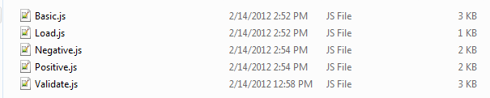
Basic.js – Contains the basic Speech tests.
Negative.js – Contains the negative Speech tests, tests that are designed to fail.
Positive.js – Contains the positive Speech tests, alternate API uses that should succeed.
Validate.js – Contains all the checks for parameters in the responses.
You edit the test cases in these folders. Below is part of the Basic.js file for the SMS tests.

API Tests
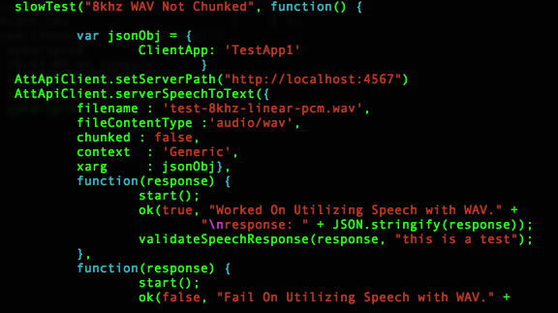
By changing the quoted section of the function in the first line, you will change the description of the test itself. Thus if you change it to ‘slowTest(“My First Test”, function(){…’ the test header for that test will then become “My First Test”.
The method call in line 20 is at the heart of the test. If the att-api-client.js file ever changes its method names (for instance,IF serverSpeechToText became SSTT), you need to duplicate the change here for the test to still work.

Response Validation Tests
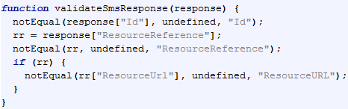
Line 2 looks for the “Id” parameter in the JSON response object and compares it to an undefined object. Since it uses the notEqual method, this function returns true if the Id parameter exists (is not equivalent to “undefined”), and false if it does not exist (is equivalent to “undefined”). The third parameter in the notEqual call, also “Id”, is the test’s label. It appears on the sweep page, showing which parameter was checked. If the JSON parameter name ever changes to, say, “id” instead of “Id”, you can change the source to response[“id”] and carry on.
Line 3 isolates the “ResourceReference” object to a variable named “rr”. There is a hope that the response contains an object named “ResourceReference”. If the variable name changes, this code would have to change too to keep up with the response object.
Line 4 checks that the ResourceReference variable exists, as was done in line 2 for Id. If ResourceReference is missing, nothing is assigned to rr. Line 5 checks for that condition, and no checks for objects inside ResourceReference are made if it is missing.
Line 6 checks for the ResourceUrl object inside the ResourceReference object. Many of the objects in JSON responses contain their own objects.
If any of the “notEqual” method calls return false, that test fails. When a parameter’s value is known, you should use the “equal” method instead.
All of the parameter validation methods follow this structure.

Modifying Throttling Setting
Often you need to adjust the throttle setting for the test calls. Making the calls too quickly causes rate limit policy errors, while sending calls slower than necessary wastes time. Typically a setting of 15000 milliseconds works well but can be increased and decreased if you have more or less api calls to make.
As an example ‘…\JTF\client\tests\STTC\Basic.js’
and modify the setTimeout method on line 14. There you set how many milliseconds pass between API calls for the entire framework. The code you work with is:
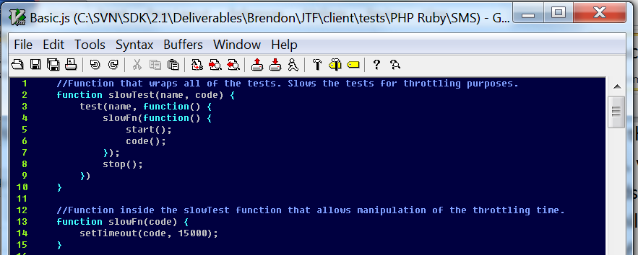

Adding to the JTF
More complicated is adding to the JTF. This is best done by taking existing methods, copying them, and updating them so they apply for the new tests. Adding a test to send an SMS to a different phone number, for instance, is simply a matter of taking a current SMS test and changing the address parameter. The tests follow the basic format shown up above, and most tests can be generated in this manner.
To make new tests part of the test suite, some additional steps must be taken.
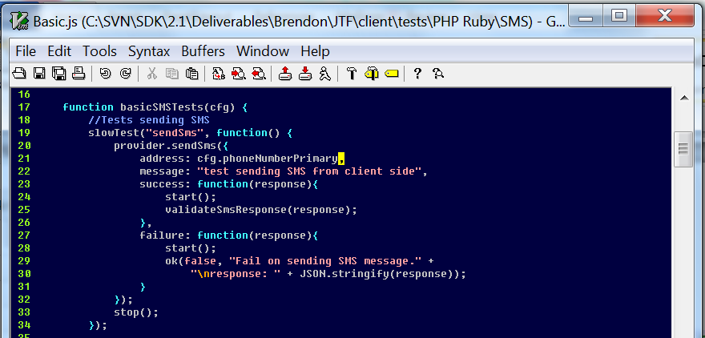
In line 17 is a declared function, with an open bracket encompassing a test. The closing bracket is not visible in this picture, because the closing bracket is at the very bottom of the file. All of the tests written in this file must be contained within this function. Any tests you add to this file must be inside the basicSMSTests(cfg) brackets.

Adding a New Test Suite
If you need to add a new test suite, perform the following:
- Create a directory with your suite name in the ‘./JTF/client/tests/<yoursuitename>
  - In the above mentioned directory is where you will keep your .js files containing the tests
- In the ‘./JTF/client/’ folder, create an HTML file with your suite name, (i.e.; SMS.html)
  - In this file, make sure to add all your test references to jQuery, qUnit, etc..
- Modify the start.html file to include a link to your test suite html.

